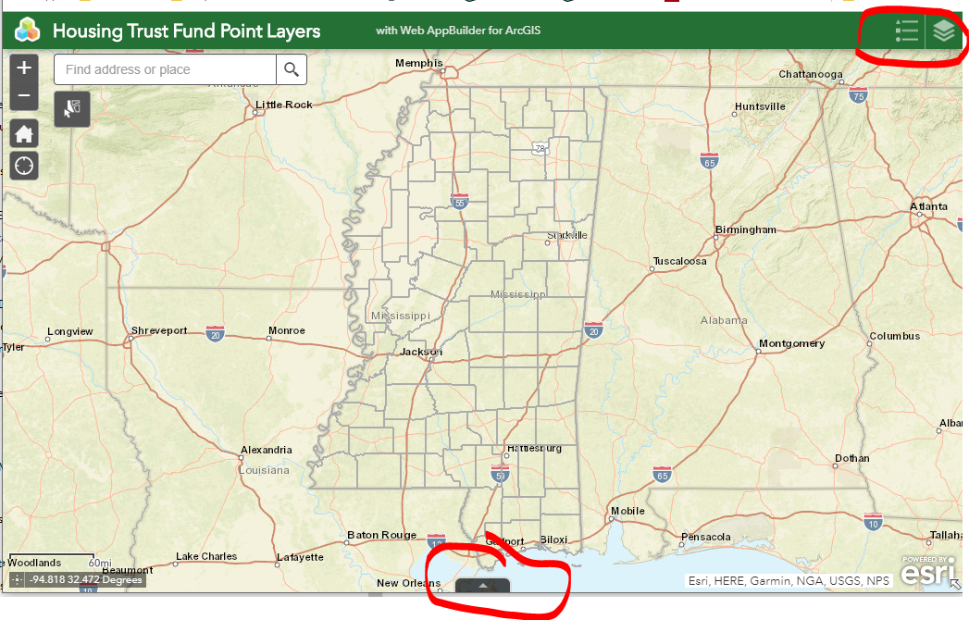

See Notes 3 , 4, 5

See Notes 1 & 2

See Note 6

Click stacked layer icon to shows layers available. Click layer to hide it.

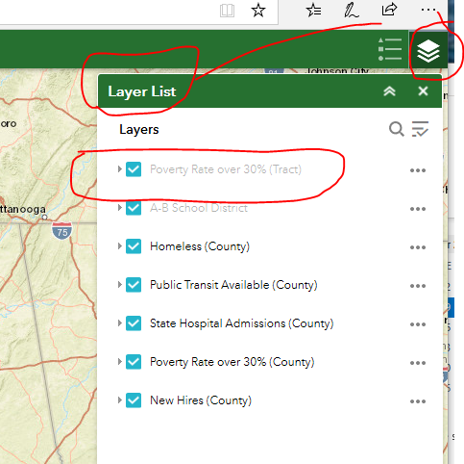

Note 1

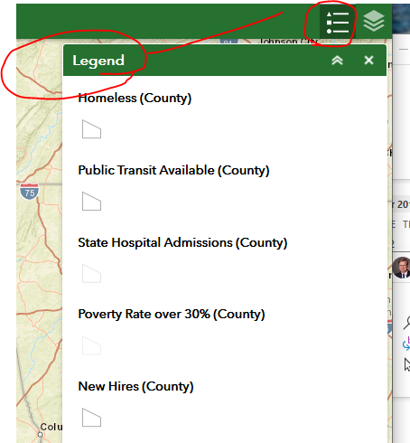

**Note 2**

Click layer to turn off or on. Depending on level of zoom, some layers are grayed out. Zoom in, they become ava

Click bullet list to show Legend detail

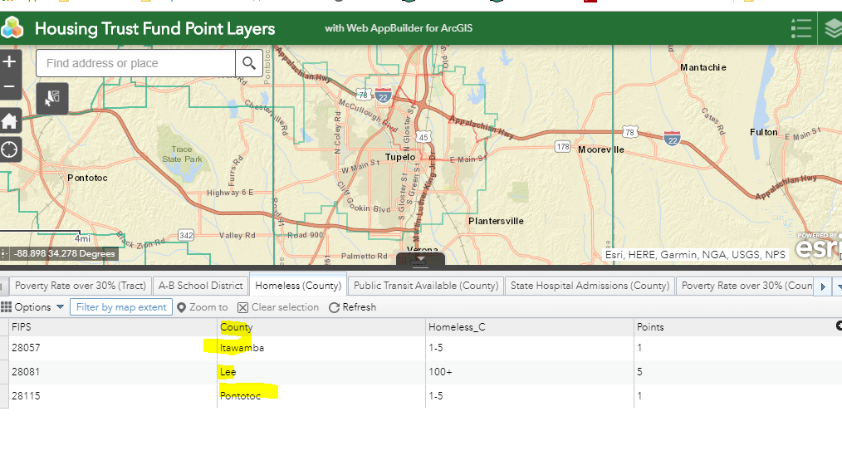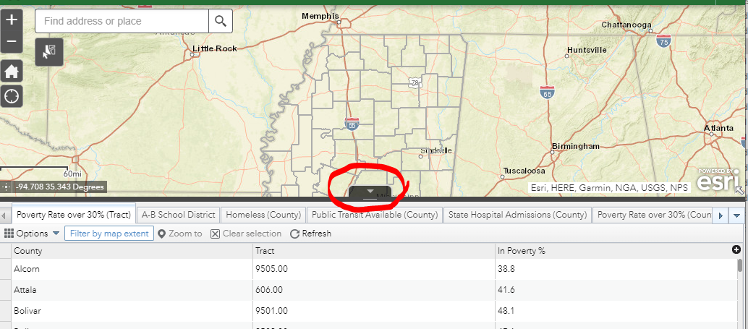

**Note 4**

Zoom in to area of interest and data is filtered to show only data for counties visible in the window

**Note 3**

Click icon to show data for active layers

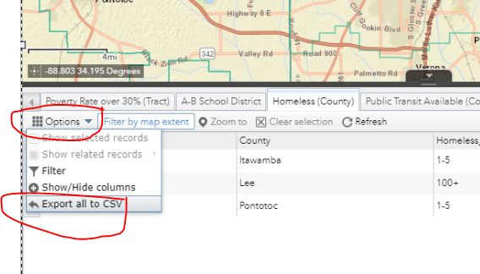

**Note 5**

Click Options button to export data

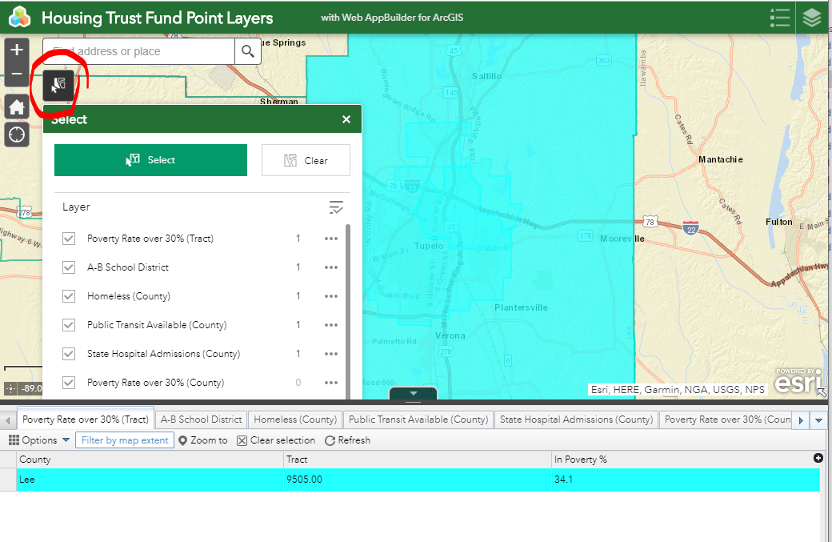

Click Clear button to clear selected layers

If tabbed data table window is open, tables are filtered to show the data for the selected layers.

Popup shows how many layers are selected

Click select button to highlight layers in an area.

**Note 6**